Louisiana Association of Professional Biologists

**2024 Scholarship Application**

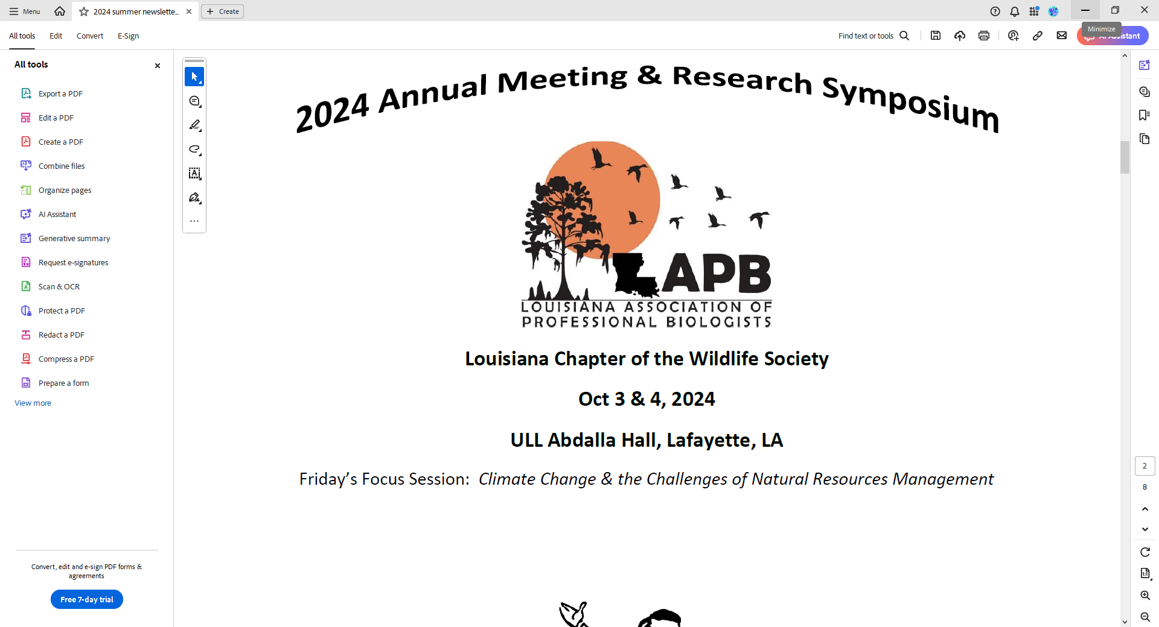**PROGRAM DESCRIPTION**

The Louisiana Association of Professional Biologists (LAPB) Scholarship is a competitive scholarship that awards $1,000.00 to a student(s) pursuing or planning to pursue college studies in the following curriculums: Wildlife Management, Fisheries Management, Forestry, Wetland Science, Marine Biology, or other closely related fields. While preference is given to incoming freshmen, all eligible students are encouraged to apply.

**ELIGIBILITY REQUIREMENTS**

Applicants must..

* …be a Louisiana resident.
* …be enrolled as a full-time undergraduate or graduate student in a Louisiana Public College or University in one of the curriculums stated above.
* …have graduated from an accredited high school or completed the 12th grade level of a home study program.
* …submit two reference letters, one of which must be from a recent schoolteacher or counselor.
* …submit a brief statement/essay with the application discussing career goals (less than 250 words).
* …submit the application and all required information by September 23, 2024.

Based on available funding and quality of applicants, more than one recipient may be chosen in any given year. Recipient(s) will be announced on the first day of the annual LAPB Fall Symposium.

Submit your application to: Larry Reynolds, Chairman, Scholarship Committee

Louisiana Department of Wildlife and Fisheries

2000 Quail Drive, Baton Rouge, LA 70808

[lreynolds@wlf.la.gov](mailto:lreynolds@wlf.la.gov)

**APPLICANT INFORMATION**

Name: Click or tap here to enter text. Birth Date: Click or tap to enter a date.

Address: Click or tap here to enter text.

Phone Number: Click or tap here to enter text. Email Address: Click or tap here to enter text.

College or University: Click or tap here to enter text. Current Year: Choose an item.

Major: Click or tap here to enter text. College GPA: Click or tap here to enter text.

(type TBD if new freshman)

High School: Click or tap here to enter text.

HS Graduation Date: Click or tap to enter a date. HS GPA: Click or tap here to enter text.

Reference #1 (Name, Position): Click or tap here to enter text.

Reference #2 (Name, Position): Click or tap here to enter text.

Write a brief statement/essay discussing your future career goals (less than 250 words).

Click or tap here to enter text.